**Algoritma :**

**Deklarasi**

**A,B,C  :integer    {koefisien-koefisien persamaan}**

**disk     : longlint  {nilai diskriminan}**

**x1,x2    : real      {nilai-nilai akar untuk disk>=0}**

**Deskripsi**

**read (A,B,C)**

**disk B*B-4*C**

**if(A=0) then write (‘bukan persamaan kuadrat’)**

**else if disk > 0 then**

**x1 (-B+ sqrt (disk)/2*A**

**x1 (-B+ sqrt (disk)/2*A**  
**else if disk = 0 then**  
**x1 (-B/2*A**  
**x2 (x1**  
**else write (‘Akar imajiner’)**  
**end if**  
**write (x1,x2)**

**Flow chart**

[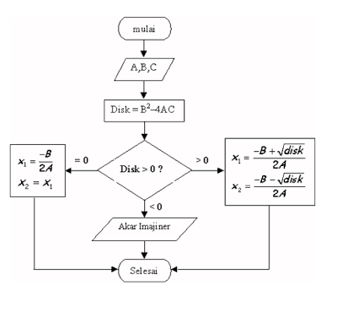](https://lh3.googleusercontent.com/-WtVN6KNGl0g/TYxe38zbUbI/AAAAAAAAACc/ZBr9aQu61FA/s1600/Capture.PNG)

**Source code**

**#include <cstdlib>  
#include <iostream>  
#include <math.h>  
  
  
using namespace std;  
class Akar {  
friend ostream& operator<<(ostream&, Akar&);  
    friend istream& operator >> (istream&, Akar&);  
  
public:  
     Akar ();  
     int disk(){ return B*B-4*A*C; }  
     float akar1() { return (-B+sqrt(disk ()))/(2*A);  
     }       
     float akar2() { return (-B-sqrt(disk ()))/(2*A);  
     }  
     void hitung_Akar ();  
     void cetak_disk () { cout << " diskriminan = " << disk () << endl; }  
     void cetak_Akar(){  
          cout<<"x1 = "<<akar1 ()<<endl;  
          cout << " x1 =" << akar2 () << endl;  
     }  
  private:  
          int A,B,C ; // input.  
          float x1,x2 ; // akar 1 dan akar 2.  
};  
          ostream& operator << (ostream& out, Akar& keluaran) {  
           keluaran.cetak_disk ();  
           if (keluaran.disk () >=0) keluaran.cetak_Akar();  
           else cout << "akar imajiner ";  
               return out ;  
  }  
          istream& operator >> (istream& in, Akar& masukkan) {  
           cout << "kooefisien pangkal 2 : " ; in >> masukkan.A ;  
           cout << "kooefisien pangkal 1 : " ; in >> masukkan.B ;  
           cout << "kooefisien pangkal 0 : " ; in >> masukkan.C ;  
          return in ;  
     }  
          Akar :: Akar () {  
           cout << " menghitung akar persamaan kuadrat\n" ;  
             
    }  
      void Akar :: hitung_Akar () {  
        if ( A==0) {  
             cout << " bukan persamaan kuadrat.\n " ;  
             cout << " Harga akar = " << -C/B; }  
             else {  
        if (disk ()> 0) {  
           x1 = akar1 ();  
           x2 = akar2 ();  
        }  
         else if (disk() == 0) {  
           x1 = akar1 ();  
           x2 = x1 ;  
       }  
      }  
    }  
  
int main(int argc, char *argv[])  
{  
         Akar kasus ;  
         cin >> kasus ;  
         kasus.hitung_Akar ();  
         cout << kasus;  
                
    system("PAUSE");  
    return EXIT_SUCCESS;**  
**}**